**Travel Experts Network**

**Configuration**

Table of Contents

Create New Listener 3

Tnsnames.ORA 7

LISTENER.ORA 8

SQLNET.ORA 9

# Create New Listener

1. In order to create a listener for the Travelxp database, open Net Manager Tool

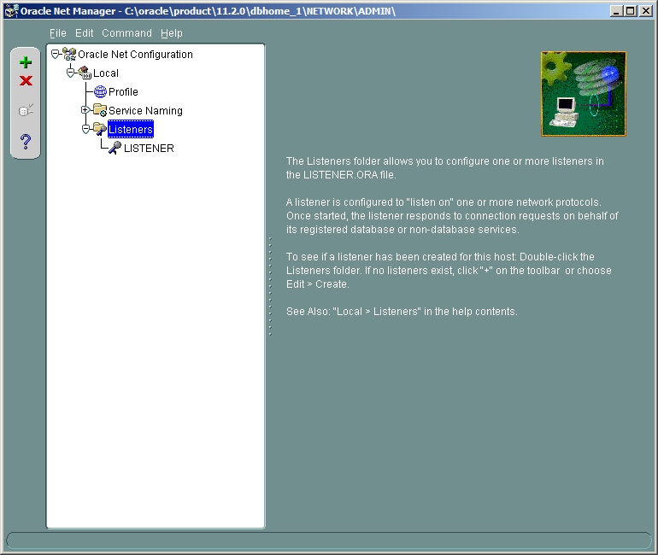

1. Click on Listener and ‘+’ sign to create a new listener. A window appears, you need to specify a proper name for the new listener (eg. Travelxp_listener).

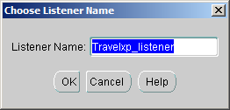

1. Click OK. You can now see the Travelxp_listener in the list of listeners.

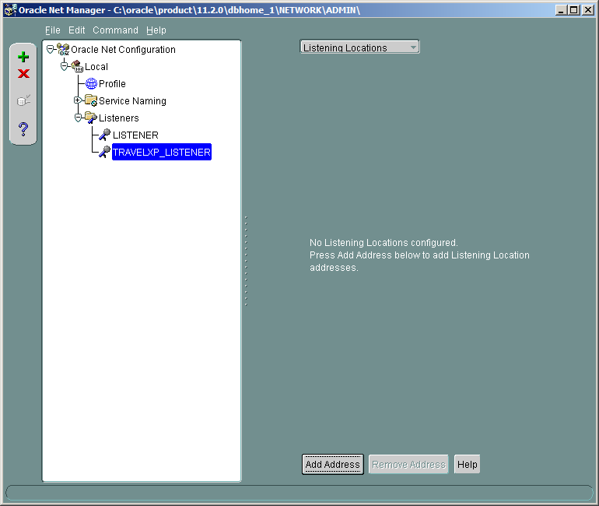

1. Click on Add Address bottom
2. Specify a new port, e.g. 1621

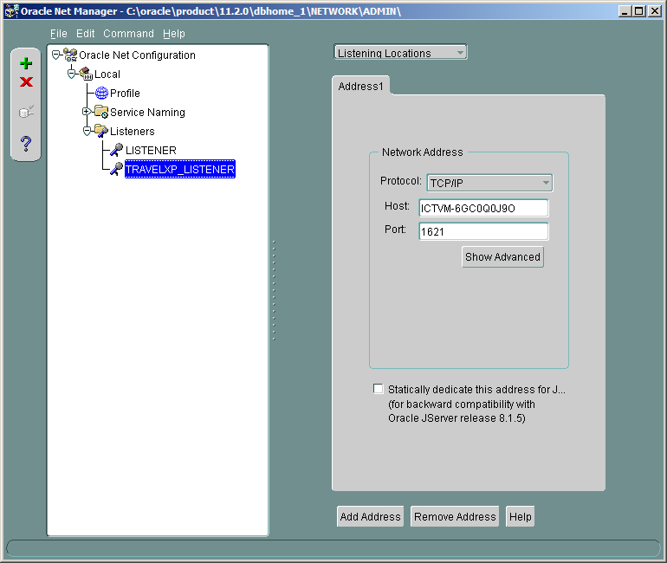

1. On top of the page, choose Database Services, then click on Add Database bottun. Now specify Global Database Name, Oracle Home Directory, and SID.

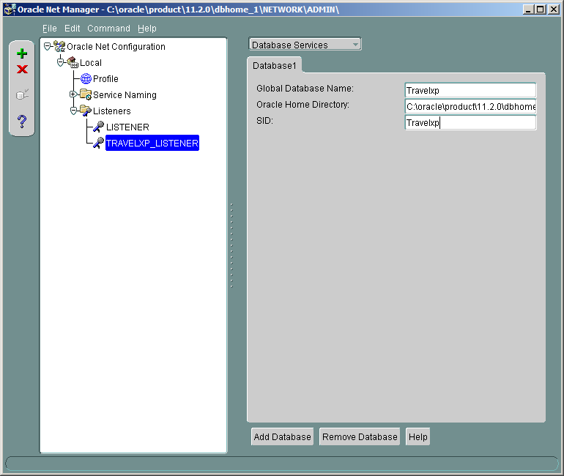

1. Save your changes from File > Save Network Configuration

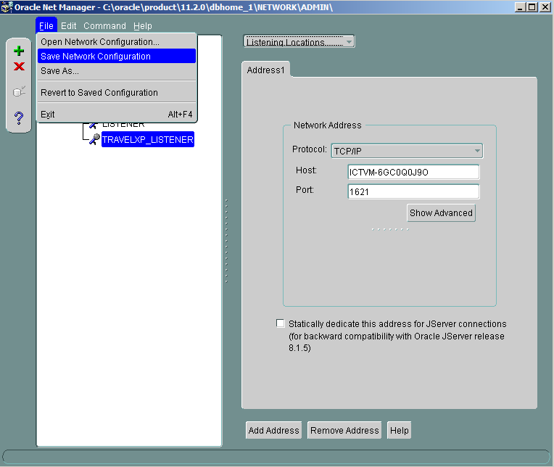8. You can now change the current listener to the new listener as follows:

* Run a cmd prompt as administrator
* C:\Windows\system32>LSNRCTL
* LSNRCTL> start travelxp_listener

OR

* LSNRCTL> set our travelxp_listener
* LSNRCTL> start

OR you can start this listener directly from services tool

* Because there is a non_default listener an entry to tnsnames.ora file must be added. To do so a new service name needs to be created for this listener by running the following command in tnsnames.ora file

TRAVELXP_SERVICE =

(DESCRIPTION =

(ADDRESS_LIST =

(ADDRESS = (PROTOCOL = TCP)(HOST = ICTVM-6GC0Q0J9O)(PORT = 1621))

)

(CONNECT_DATA =

(SERVICE_NAME = TRAVELXP)

)

)

OR

* Create a new service_name by “Net Manager Tool.” It will add this command into tnsnames.ora file automatically.
* If using Net Manager Tool set the following parameters as follows:

1. **Net Service Name**: Travelxp_service (a proper name)
2. **Protocol:** TCP/IP
3. **Port Number:**1621 (the port you used for new listener)
4. **Service Name:** Travelxp
5. **Test** by agent/agent28#
6. If other clients need to connect by this listener, **Open Port**: 1621

# Tnsnames.ORA

# tnsnames.ora Network Configuration File: C:\oraclexe\app\oracle\product\11.2.0\server\network\ADMIN

# Generated by Oracle configuration tools.

XE =

(DESCRIPTION =

(ADDRESS = (PROTOCOL = TCP)(HOST = Nickzad)(PORT = 1521))

(CONNECT_DATA =

(SERVER = DEDICATED)

(SERVICE_NAME = XE)

)

)

TRAVELXP =

(DESCRIPTION =

(ADDRESS = (PROTOCOL = TCP)(HOST = Nickzad)(PORT = 1521))

(CONNECT_DATA =

(SERVER = DEDICATED)

(SERVICE_NAME = TRAVELXP)

)

)

EXTPROC_CONNECTION_DATA =

(DESCRIPTION =

(ADDRESS_LIST =

(ADDRESS = (PROTOCOL = IPC)(KEY = EXTPROC1))

)

(CONNECT_DATA =

(SID = PLSExtProc)

(PRESENTATION = RO)

)

)

ORACLR_CONNECTION_DATA =

(DESCRIPTION =

(ADDRESS_LIST =

(ADDRESS = (PROTOCOL = IPC)(KEY = EXTPROC1))

)

(CONNECT_DATA =

(SID = CLRExtProc)

(PRESENTATION = RO)

)

)

# LISTENER.ORA

# listener.ora Network Configuration File: C:\oraclexe\app\oracle\product\11.2.0\server\network\ADMIN

# Generated by Oracle configuration tools.

ADR_BASE_LISTENER = C:\oraclexe

TRAVELXP =

(DESCRIPTION =

(ADDRESS = (PROTOCOL = TCP)(HOST = Nickzad)(PORT = 1521))

)

LISTENER =

(DESCRIPTION_LIST =

(DESCRIPTION =

(ADDRESS = (PROTOCOL = IPC)(KEY = EXTPROC1))

)

(DESCRIPTION =

(ADDRESS = (PROTOCOL = TCP)(HOST = Nickzad)(PORT = 1521))

)

)

SID_LIST_TRAVELXP =

(SID_LIST =

(SID_DESC =

(GLOBAL_DBNAME = Travelxp)

(SID_NAME = Travelxp)

(ORACLE_HOME = C:\oraclexe\app\oracle\product\11.2.0\server)

(PROGRAM = extproc)

)

(SID_DESC =

(SID_NAME = Travelxp)

(ORACLE_HOME = C:\oraclexe\app\oracle\product\11.2.0\server)

(PROGRAM = extproc)

)

)

SID_LIST_LISTENER =

(SID_LIST =

(SID_DESC =

(SID_NAME = PLSExtProc)

(ORACLE_HOME = C:\oraclexe\app\oracle\product\11.2.0\server)

(PROGRAM = extproc)

)

(SID_DESC =

(SID_NAME = CLRExtProc)

(ORACLE_HOME = C:\oraclexe\app\oracle\product\11.2.0\server)

(PROGRAM = extproc)

)

)

LISTENER =

(DESCRIPTION_LIST =

(DESCRIPTION =

(ADDRESS = (PROTOCOL = IPC)(KEY = EXTPROC1))

(ADDRESS = (PROTOCOL = TCP)(HOST = Nickzad)(PORT = 1521))

)

)

DEFAULT_SERVICE_LISTENER = (XE)

# SQLNET.ORA

# sqlnet.ora Network Configuration File:

C:\oraclexe\app\oracle\product\11.2.0\server\network\ADMIN

# Generated by Oracle configuration tools.

# This file is actually generated by netca. But if customers choose to

# install "Software Only", this file wont exist and without the native

# authentication, they will not be able to connect to the database on NT.

SQLNET.AUTHENTICATION_SERVICES = (NTS)

NAMES.DIRECTORY_PATH = (TNSNAMES, HOSTNAME, EZCONNECT)

ADR_BASE = C:\oraclexe\app\oracle\product\11.2.0\server\log